- UniversalAuto.com is an online website which allows the users to book and rent car for vacation. The company’s service areas include the whole country of Malaysia. The website allows users to view available car models, rental fee, make booking, and make payment. A booking number will be generated once the payment is confirmed. Recently UniversalAuto.com is planning to extend their website on mobile platform as mobile users are increasing dramatically

Propose 4 user interface designs principles to UniversalAuto.com mobile application.
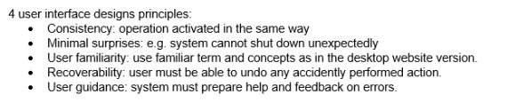
- What are the 2 elements that must be put into attention in presenting information while designing a mobile game for children age 5-7 years old? Explain your answer with appropriate example.
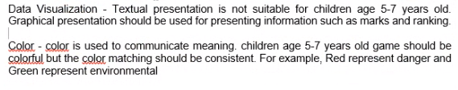
- Furious Movies Cinema is approaching your company to implement an online cinema ticketing system. Suggest and explain 4 good user interface design principles to the system to ensure screen usability.

- Around The Globe (ATG) Sdn Bhd is a travelling agency that is owned by family Berth since 1960s. The company is using a high quality legacy system to manage the staff and customers’ information. However, the maintenance cost is increasing recently as a system requires Pascal experts. Seeing that this system has low business value to the company, Berth Junior (CEO of ATG) consults your company regarding the legacy system’s management strategy.

Berth Junior is complaining about the legacy system’s usability (user interface design). Explain to Berth Junior 3 golden rules for a good user interface design that your company normally applies.
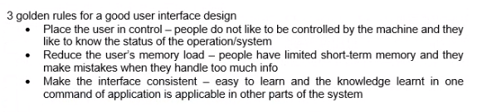
- SmartOffice.com is a newly established company which designs and implements Internet of Things (IoT) in offices such as automation of lighting during night and in the washroom, office air-con automated temperature detection and adjustment, video monitoring system, and et cetera. The company is approaching you to develop an Online Customer Service System which eases their customers to contact their sales representative whenever they have problems with the technology. The website should be available 24x7. There will be a group of sales representatives answering the customers’ questions through online chat or email.

Suggest and explain 4 user interface designs principles that must be included in the Online Customer Service system.

